**EasyEnroll Online Course Software Hosted on WordPress in XAMPP Instructions**

Jeremy Roosa

The University of Arizona Global Campus

CST 499: Capstone for Computer Software Technology

Instructor: Amr Elchouemi

January 18, 2022

Please see the following is the contents of the zip file that I submitted. The wordpress folder and its contents should be placed in the htdocs folder under the XAMPP folder on your local machine. The easy_enroll.sql file is an exported database from phpMyAdmin that will need to be imported into your phpMyAdmin later. This process will be discussed later.

Figure 1.1 Assignment Submission Zip Folder Contents

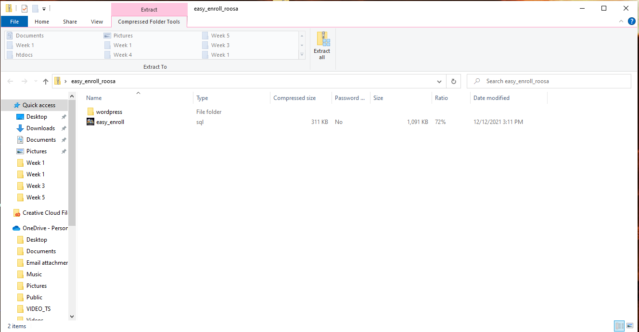

Right click the zip folder and extract the files to a location of your choosing. I chose to extract them to my desktop.

Figure 1.2 Extracting files

As previously stated, copy and paste the wordpress folder that was submitted in the zip file that was extracted into the htdocs folder wherever XAMPP was installed on your local machine.

Figure 1.3 htdocs folder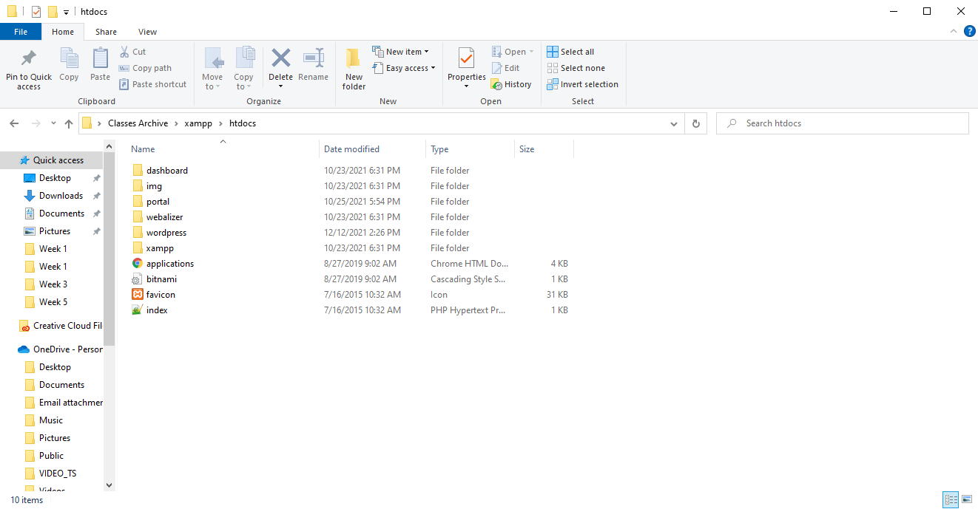

Open XAMPP and ensure your XAMPP Apache and MySQL processes are running.

Figure 1.4 XAMPP process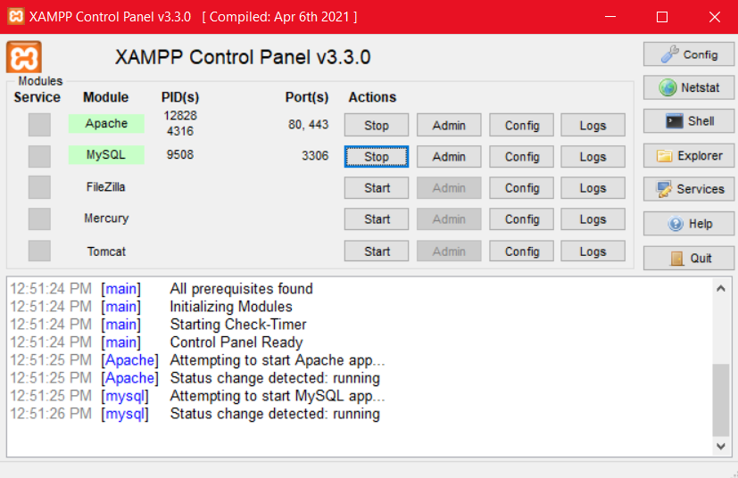

The next step is to create a database on your phpMyAdmin named easy_enroll. Click Databases and enter the information as I have as seen below in Figure 1.5.

Figure 1.5 Create a database

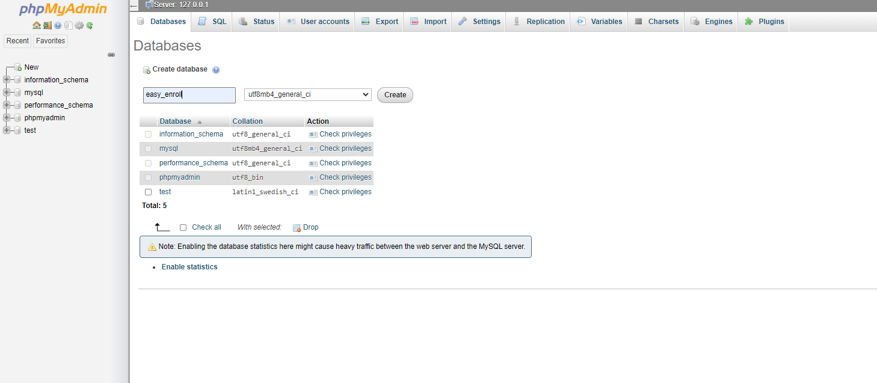

Now you must navigate back to the main screen using the button that is highlighted below in Figure 1.6.

Figure 1.6 Navigation

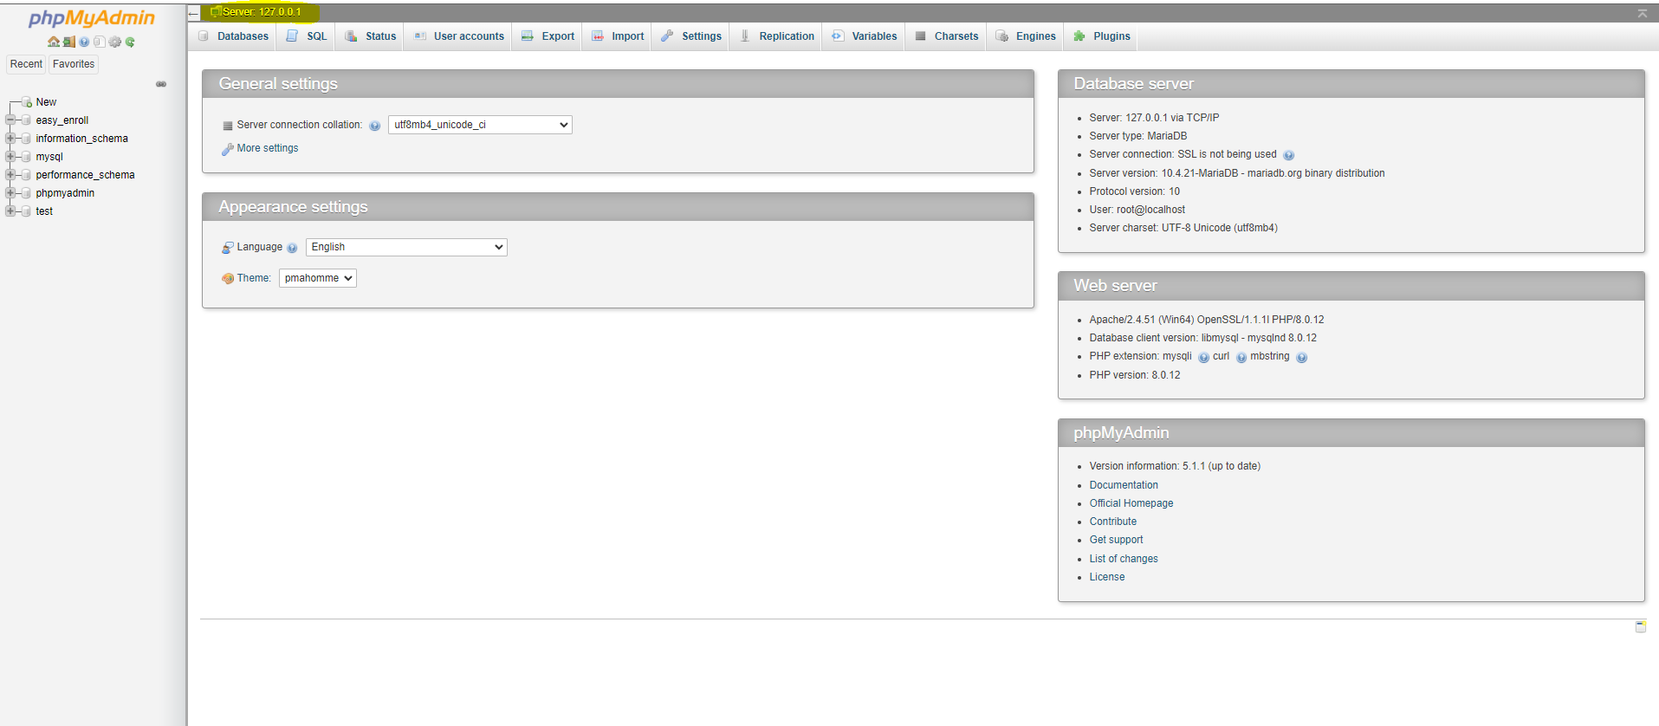

Click the User Accounts button as highlighted below in Figure 1.7.

Figure 1.7 Click user accounts

Click the Add user account button as highlighted below in Figure 1.8.

Figure 1.8 Click Add user account

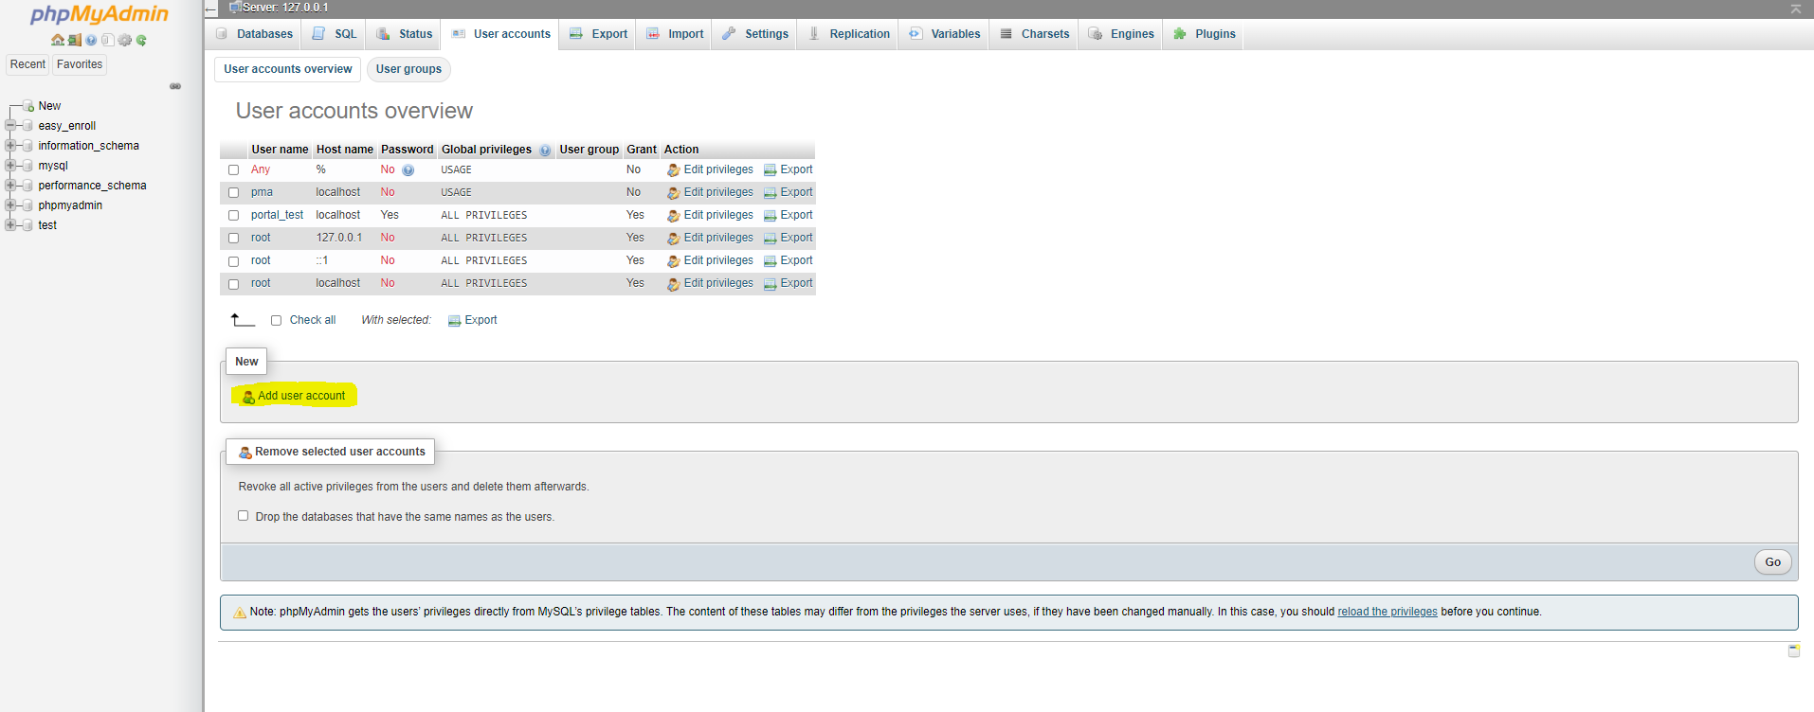

Ensure you enter the information into the software the same as I have as seen below in Figure 1.9. The username should be easy_enroll. The Host name must be localhost. The password should be password. Ensure to check Grant all privileges on wildcard name and Check all under Global privileges as highlighted below. Finally hit Go at the bottom of the screen as highlighted.

Figure 1.9 Enter Data and Hit go

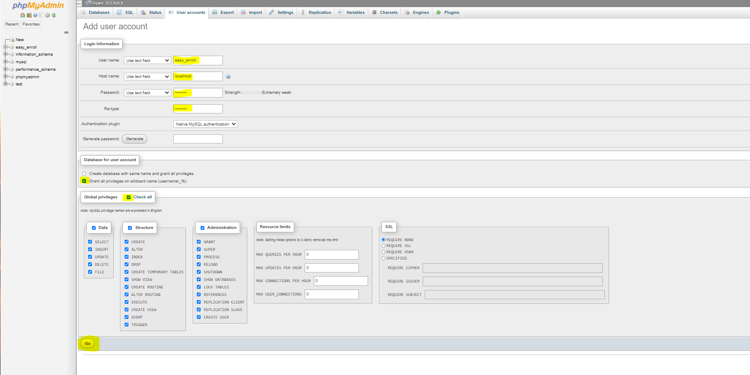

Hit Go once more as seen in Figure 1.10.

Figure 1.10 Hit Go once more

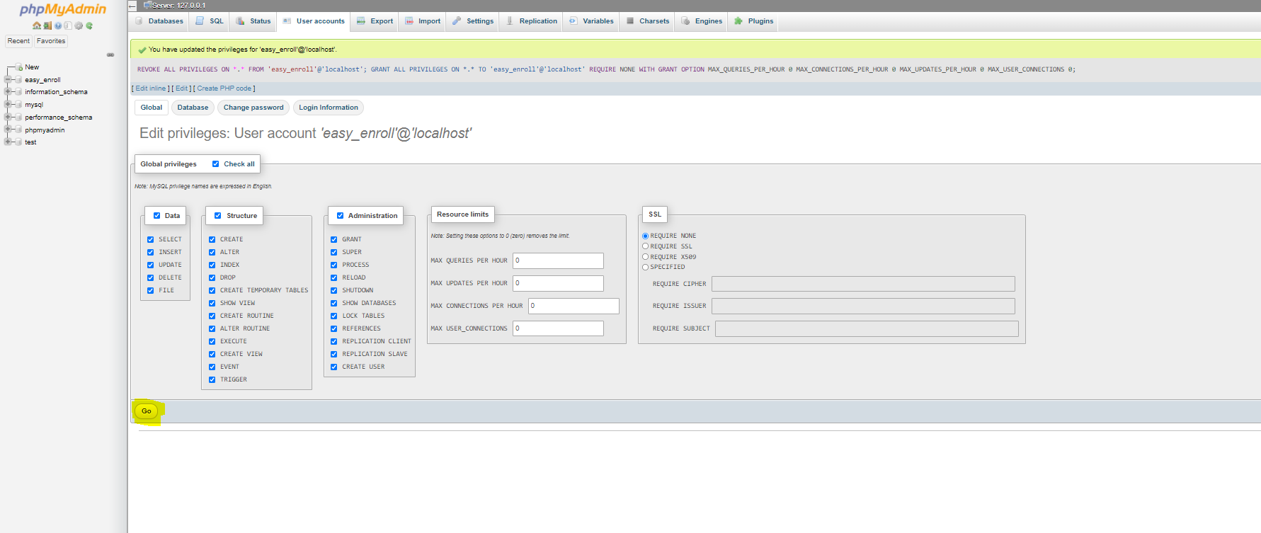

Navigate back to the database that you created titled easy_enroll by clicking the database on the left as seen in Figure 1.11.

Figure 1.11 Navigate back to easy_enroll

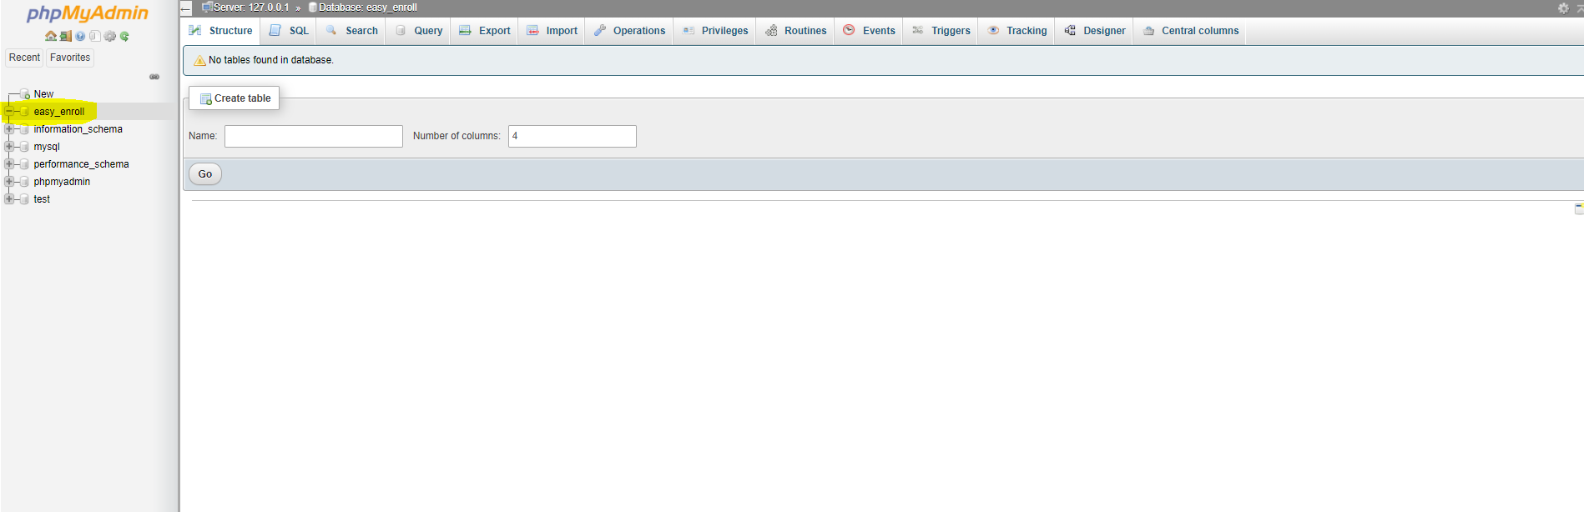

Click the import button as highlighted below in Figure 1.12.

Figure 1.12 Click Import

Click Choose File as seen highlighted in Figure 1.13 and select the easy_enroll.sql file from the unzipped folder saved in previous steps. Hit go in the bottom right hand corner of the screen once this is accomplished.

Figure 1.13 Choose the correct easy_enroll.sql file from your unzipped folder.

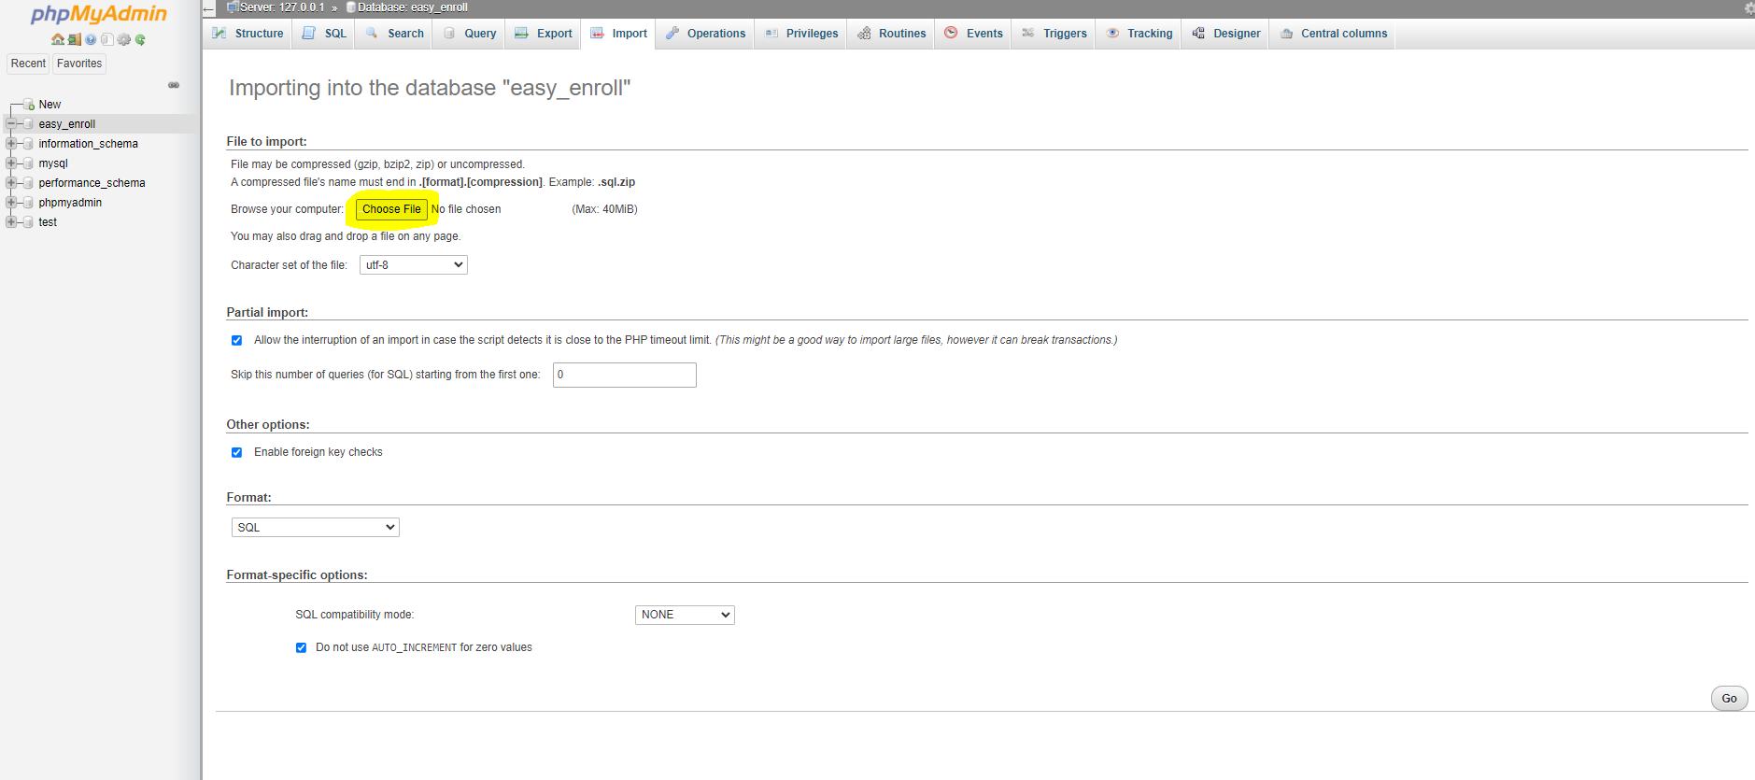

The Database should populate with the tables and data as seen in Figure 1.14

Figure 1.14 Database Population

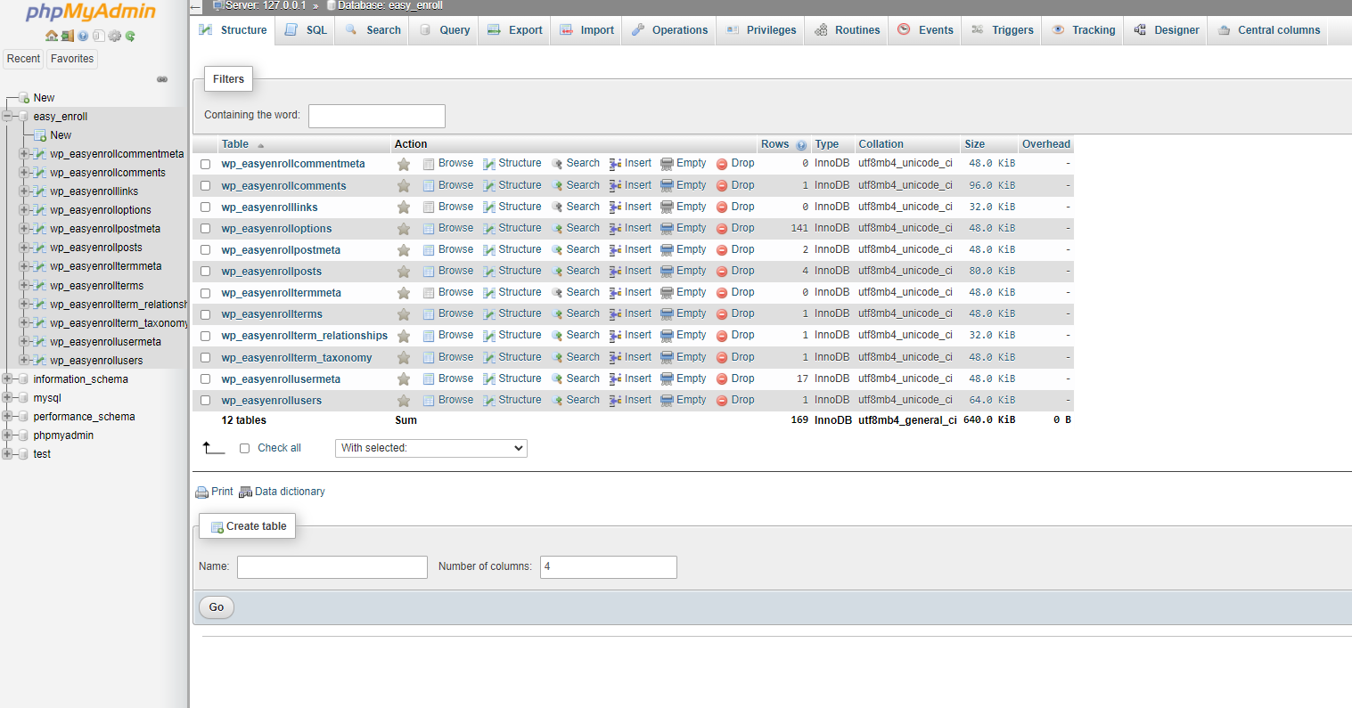

Once the database is imported, type localhost/wordpress into your browser of choice as seen highlighted below in Figure 1.15.

Figure 1.15 Type into Browser

The following steps in Figure 1.16 through Figure 1.19 may not be necessary as the website may populate automatically. If not, please choose a language as seen in Figure 1.16.

Figure 1.16 Setting up WordPress

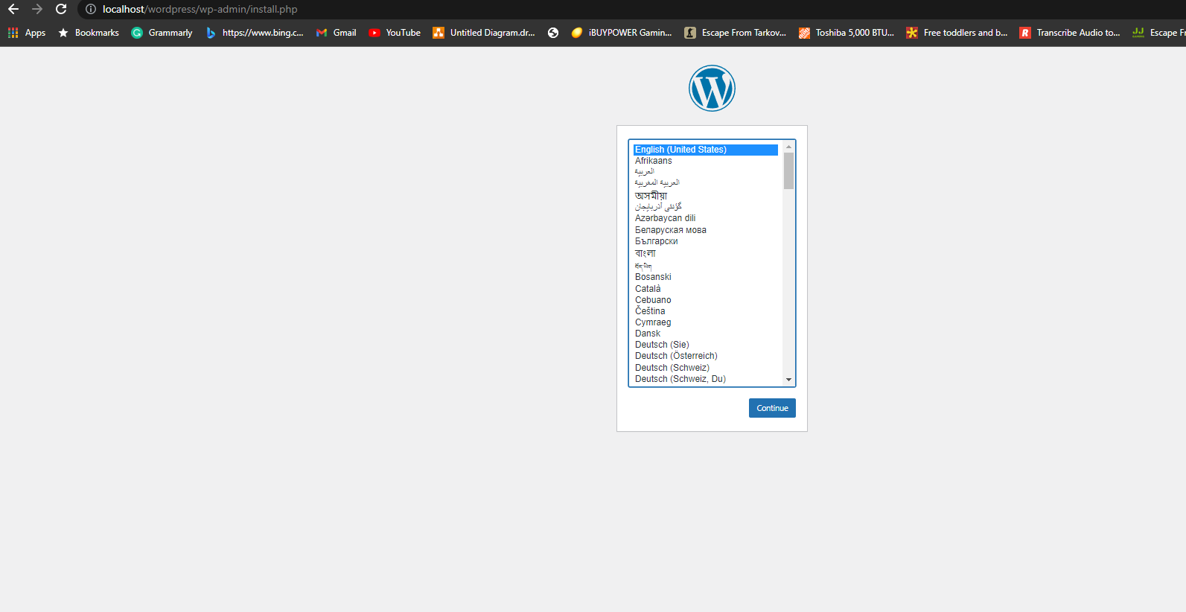

As seen in Figure 1.17 enter the information as depicted below. Hit Install WordPress once populated. Enter your own email address as applicable.

Figure 1.17 Install WordPress

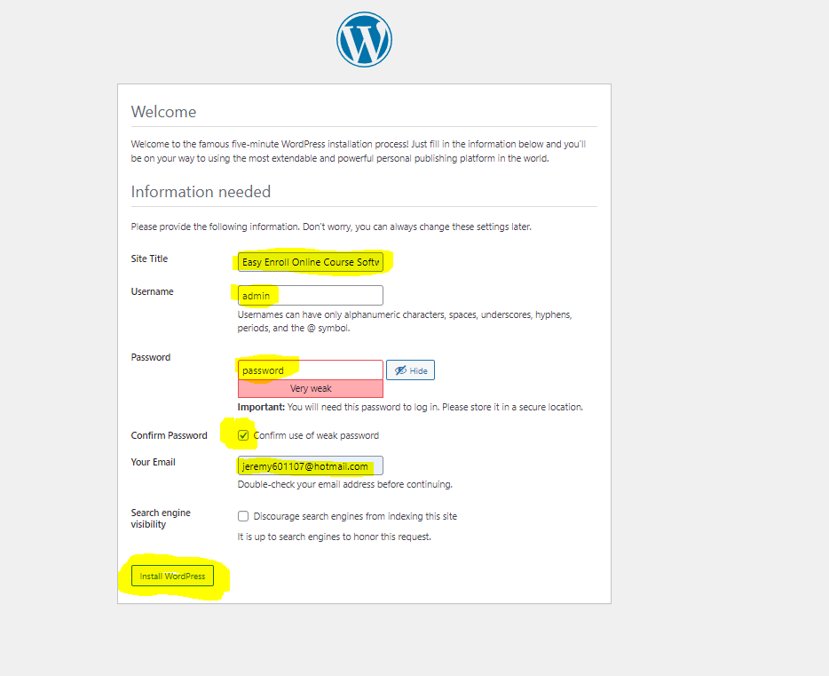

Log into the system using the admin account with the username as admin and password as password.

Figure 1.18 Log In

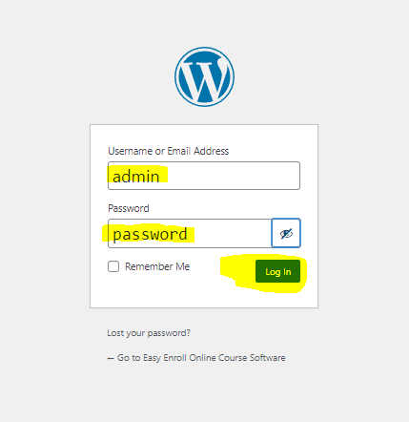

Finally, hit the highlighted Log In button as seen in Figure 1.19.

Figure 1.19 Successful Load

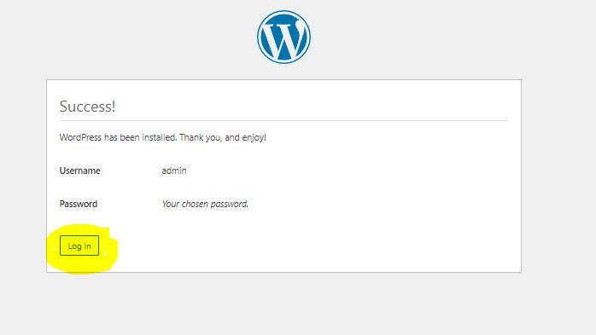

The working website that the student created should populate and be interactable after logging in. One can see that the courses section has been uploaded.

Figure 1.20 Working Website

